Knock Sensor

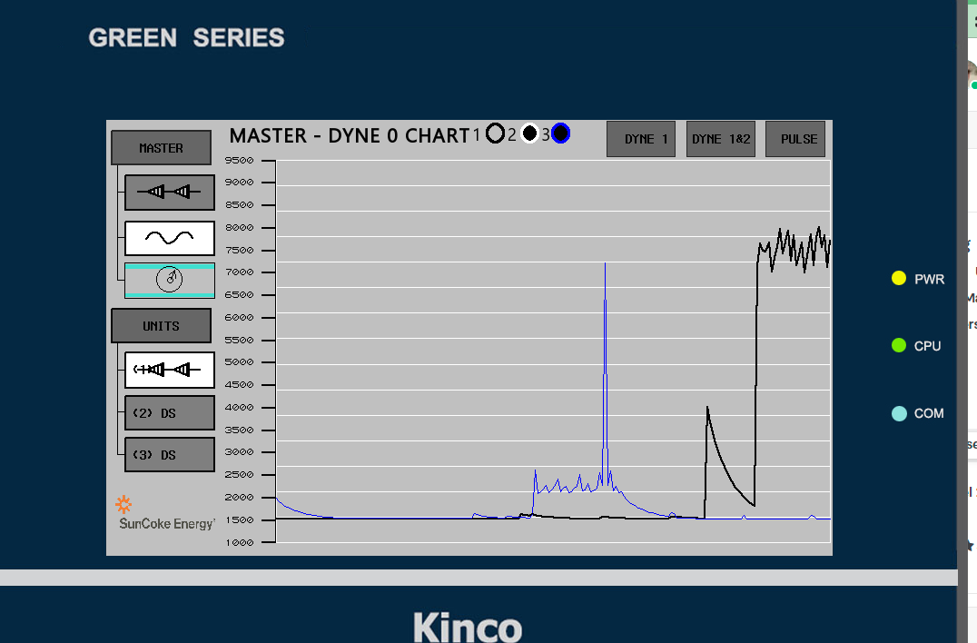

Blue is RST on PO-2, trigger

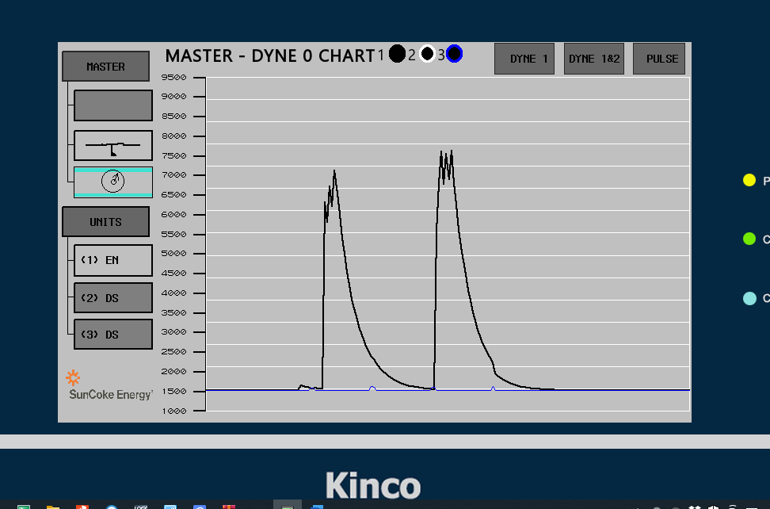

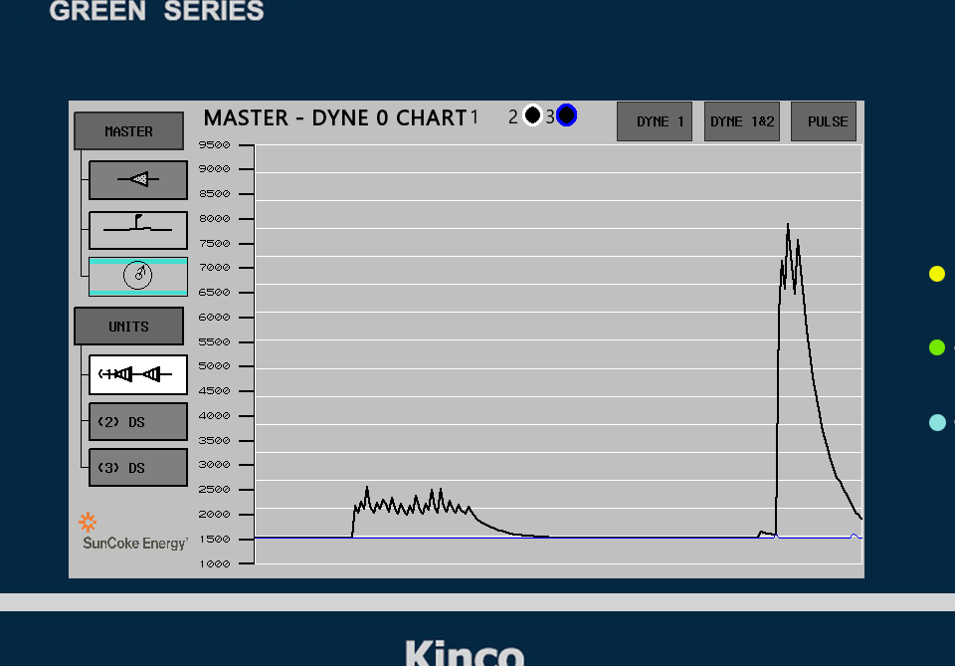

Black is 12V on RST, PO-1. Voltage is over 360R, V x 100